Handout 2.

Market risk OF portfolios, bonds and derivatives

Compulsory reading:
Hull: Risk management and Financial Institutions, Chapter 14, 15, 27

Key terms:
- Historical simulation
- Delta normal method
- Monte Carlo simulation
- Backtesting
- Binomial distribution
- Kupiec-test
- Duration
- Modified duration
- Black-Scholes formula
- call/put option
- delta

Formulas:

Binomial distribution:
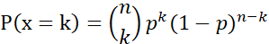

Kupiec test:

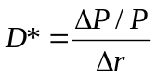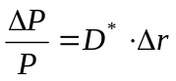

In the case of effective return: 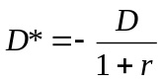
In the case of logreturn: 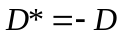

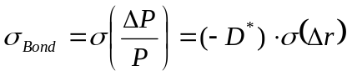

Assuming the change of the interest rate follows normal distribution with zero mean:

A Black-Scholes formula:

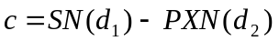
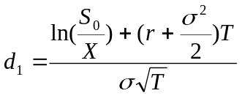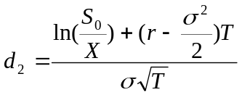

in Visual Basic:

Function BS(S, K, szigma, r, T)
Dim L, P, d1, d2, N1, N2
L = szigma * T ^ 0.5
P = Exp(-r * T)
d1 = (Log(S / K) + (r + szigma ^ 2 / 2) * T) / L
d2 = d1 - L
N1 = Application.NormSDist(d1)
N2 = Application.NormSDist(d2)
BS = S * N1 - P * K * N2
End Function

Exercises:

- You can find the daily closing prices of the last 3 years for some Hungarian stocks (MOL, OTP, TELEKOM) in Excel (downloaded from https://bse.hu/pages/data-download). Based on the data of the daily effective returns, calculate the daily Value at Risk and Expected Shortfall at a confidence level of 99%
  - for each stock using simple historical simulation;
  - for each stock using exponentially declining weights (λ=0.98);
  - for each stock supposing the effective returns are normally distributed;
  - for a portfolio consisting 1000 of each stock, using simple historical simulation;
  - for a portfolio consisting 1000 of each stock, using historical simulation with exponentially declining weights (λ=0.98)!
  - for a portfolio consisting 1000 of each stock supposing the joint distribution of the portfolio’s return is normal.

- The RM Bank has a model supposing that MOL share price follows GBM. The bank calculated the 1-day value-at-risk at 99% confidence level every day, based on the data of the last year (250 days). Backtest the model for the last 3 years! Interpret the results and test the validity of the model at 95% significance level.

- The yield curve is flat at 5%. The modified duration of a treasury bond is 3.5 and the volatility of the changes of the 3.5 point of the yield curve is 100 bp. Calculate the annual VaR at 95% confidence level, assuming the yield changes are normally distributed, and the expected value of the return is neglectable!

- The price of a stock follows GBM with the parameters μ=20% σ=30%. The spot price is S=1000. The riskfree logreturn is 10%.
- Calculate the 1-day VaR at a confidence level of 95% of an ATM plain vanilla European call option with a maturity of 1 year.
- Calculate the 1-day VaR at a confidence level of 95% of a straddle position consisting of an ATM call and put with a maturity of 1 year! Use MC simulation.

- Case study
The case:
On December 6 1994, Orange County, a prosperous district in California, declared bankruptcy after suffering losses of around $1.6 billion from a wrong-way bet on interest rates in one of its principal investment pools. The pool was intended to be a conservative but profitable way of managing the county’s cashflows, and those of 241 associated local government entities. Instead, it triggered the largest financial failure of a local government in US history.
Based on your own research, answer the following questions.

Questions:
- What is the “yield curve play” (also called riding the yield curve)?
- What was the investment strategy of Bob Citron?
- What was the main risk factor the portfolio was exposed to? What was the reason of the losses?
- How could the risk be measured? Calculate risk measures for the portfolio with different methods!
- How could the losses have been avoided or controlled?

